Options D and O User Guide

Author: Pesticide Reporting Service Bureau
Software Version: Current
Document Revision Date: 2015.12.01
Table of ContenTs
2 Overview 3
3 Using the Workbooks 4
3.1 Decide Which Forms to Use 4
3.2 Form Header 4
3.3 Data Entry Grid 5
3.4 Report Forms 5

Overview
Pesticide Reporting Software Option D is a set of four formatted Microsoft Excel workbooks designed to assist you in electronically recording Pesticide Reporting Law (PRL) information and reporting it to the NYS Department of Environmental Conservation. This option is recommended only for users who have expertise with Excel but cannot use any of the other Options (e.g., users who cannot run Windows-based programs or Excel workbooks with VBA Macros). These workbooks provide little assistance to the user except for formatting the PRL spreadsheets and Excel-based validation. There is no built-in assistance for uploading a PRL report to the NYSDEC.
Pesticide Reporting Software Option O is a nearly identical set of workbooks that can be used with Excel-compatible spreadsheet programs such as Apple’s Numbers or OpenOffice.org’s Calc. In order to work with Excel-compatible applications, Option O does not use Excel-based validation and there is no worksheet protection.
Option D runs under Microsoft Windows® and Macintosh OS. Microsoft Excel is required.
Option O runs under Microsoft Windows® and Macintosh OS. A spreadsheet application which can edit Microsoft Excel workbooks is required. Option O is available in both XLSX and XLS formats.
Neither option requires installation; just download the Option D or Option O workbooks you require. Note that the workbooks for each form type must be downloaded separately.
If you need further assistance, contact the Pesticide Reporting Service Bureau.

Using the Workbooks

Decide Which Forms to Use
If you have multiple applicators to include on your report, we recommend using a Form 26A to enter their information. The pesticide applications they made should be entered on a Form 26. If any of the applicators that you are reporting for made any applications during the report year, you should submit a Form 26.
You may enter all your applications in one file even if they were made by multiple applicators; we do not need a separate report for each applicator.
If you are reporting for a pesticide sales business and you sell restricted use pesticides, use Form 25. If you sell pesticides to private applicators, we will need a Form 27. If you have a commercial permit number, you must submit either a Form 25 or a Form 27 or both.
Be sure to include applicators who did not make applications on your report and applicators who left your organization during the report year. If your organization is a pesticide sales business, you must file a report even if you did not make any sales during the report year.
You can report two different types of sales on Form 25; report either sales to another commercial permit holder who will resell the products or sales to commercial applicators for their end use. In Options A and B there are a set of radio buttons in the Form 25 header where you can specify the sales type. Options D and O have drop down lists for specifying the sales type. If you have both types of sales to report, please send us a separate form for each type. However you do not need to complete a form for the type of sales you did not make (but you still need to report even if you did not make any sales).

Form Header
Each form has one or more identification numbers in the header area appropriate to the form type. These identification numbers are used to associate your report with the correct applicator(s) or organization. If you are required to fill out a particular form type, you must also fill out the identification numbers and associated name field in the header area.

The business registration number is not required on Form 26, but you should submit it if you have one so that we contact you as needed. If you have more than one business registration number, see this FAQ.

All applicators and pesticide sales businesses are required to report even if they did not make any applications or sales. See Reporting No Applications or Sales for more information.
The forms also include a report year field in the header area. This field is also required. In addition, links to this documentation in three different formats are included.

Data Entry Grid
Both Option D and O contain descriptions for each column in the column heading comments. Click in the cell and the cell comment will appear. Option D also contains the column descriptions in small popup windows that appear when you click in a cell.

The popup windows that appear when you click on a cell in the data entry grid of Option D can be moved. Just click in the popup and drag it while holding the mouse button down.

In Option D some columns are validated. If the data you enter does not conform to the criteria for the column, Excel will display a descriptive error message. You will need to correct (or delete) the data in the cell before moving to the next cell. If you need more information about a particular column, complete field descriptions can be found in the Record Layouts section or the Data Dictionary.

Report Forms
Each form is used to report a particular type of pesticide-related activity.
Figure 1 Form 26
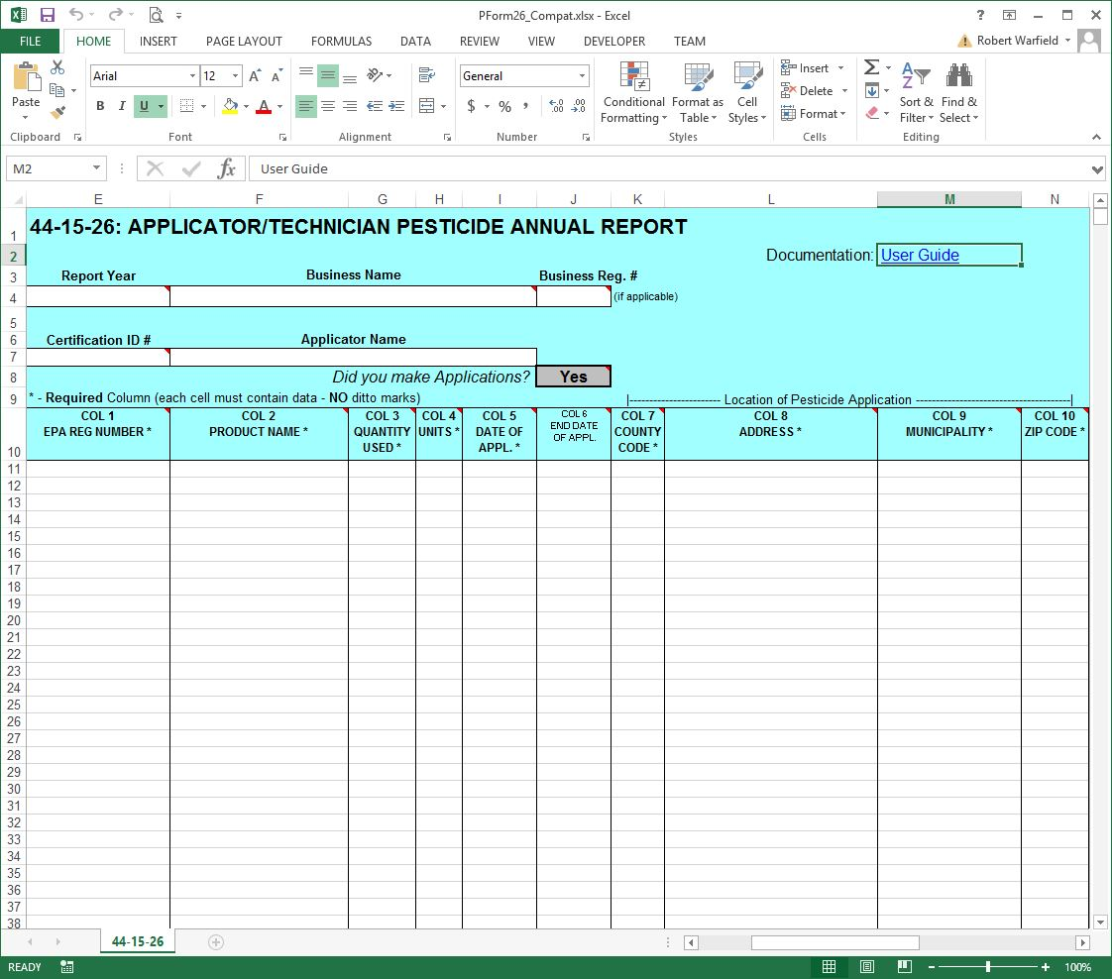
Figure 2 Form 26A
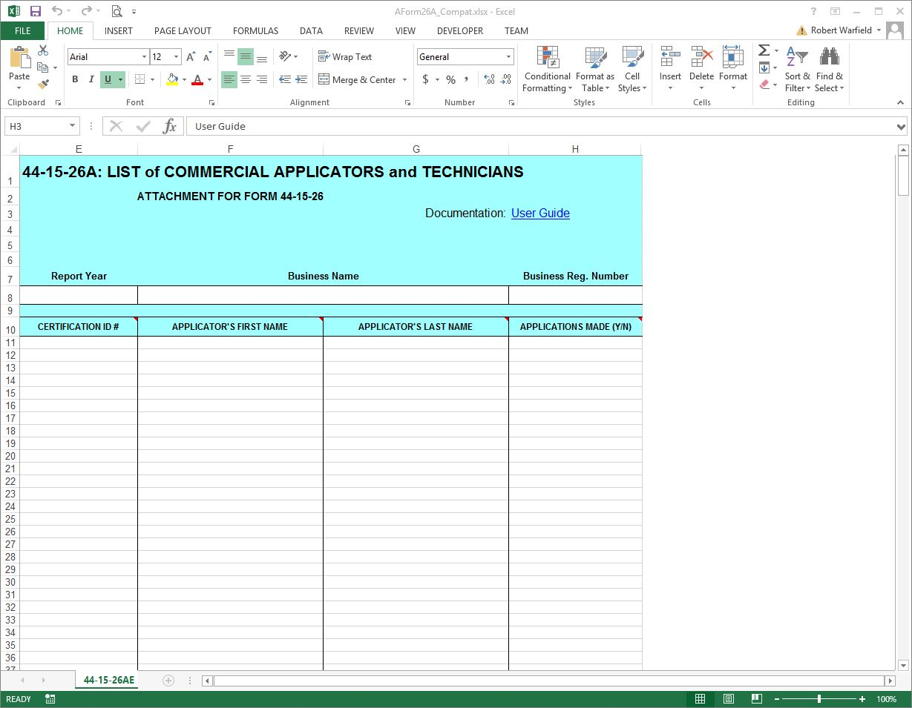
Figure 3 Form 27
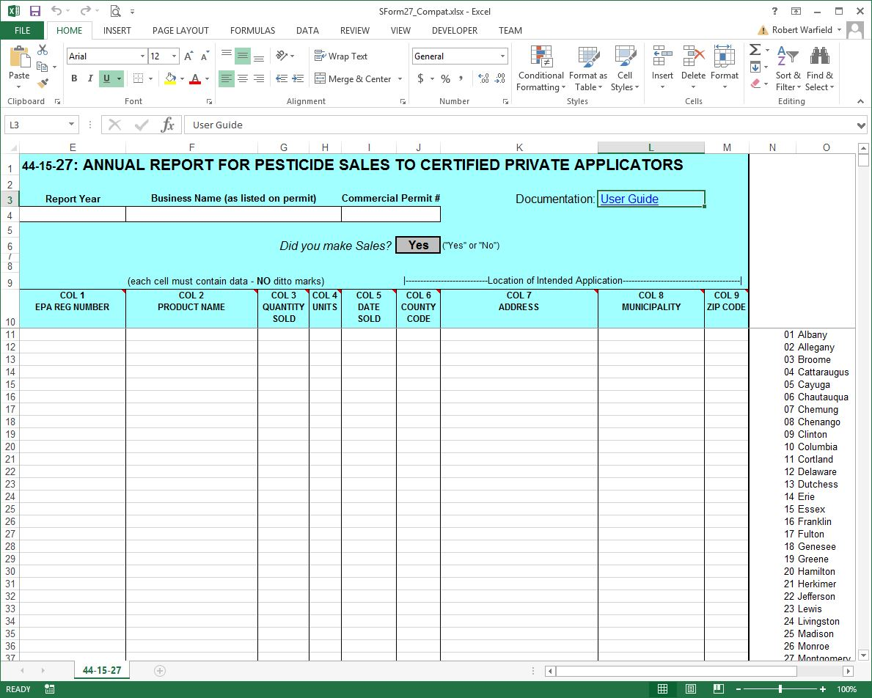
Figure 4 Form 25
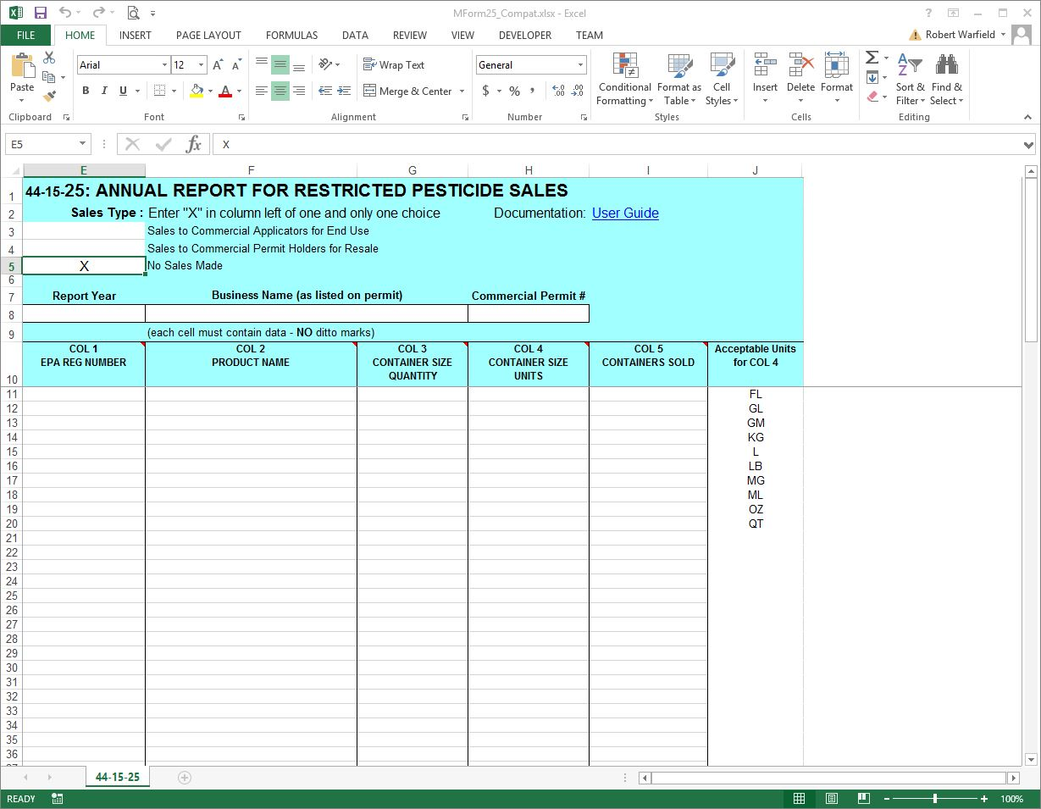
Form 26
Reporting Columns - For each product in each pesticide application, report these fields using Form 26. All columns are required except for the End Date.
1. EPA Registration Number
2. Product Name
3. Quantity
4. Units of Measure
5. Application Date
6. End Date
7. County Code
8. Address
9. Municipality
10. Zip Code

Record Keeping Columns - These columns are optional; you may use them to fulfill the record keeping requirements of the PRL.
11. Dosage Rate
12. Method of Application
13. Target Organism(s)
14. Place of Application

Form 26A
For each commercial applicator, technician and anti-fouling applicator report these fields using Form 26A. All columns are required.
1. Certification ID Number
2. Applicator First Name
3. Applicator Last Name
4. Applications Indicator

Form 27
For each sale of restricted use pesticides or general use agricultural pesticides to certified private applicators, report these fields using Form 27. All columns are required.
1. EPA Registration Number
2. Product Name
3. Quantity
4. Units of Measure
5. Application Date
6. County Code
7. Address
8. Municipality
9. Zip Code

Form 25
For each container size of each restricted use pesticide sold to New York purchasers, report these fields using Form 25. All columns are required.
1. EPA Registration Number
2. Product Name
3. Container Size Quantity
4. Container Size Units
5. Containers Sold

